**Staff development on Big Data Analytics using R**

Twelve (12) Rwanda Revenue Authority (RRA) staff followed the training for ***R for data science*** (R programming language). The training was held in the offices of Planning and Research Department.  
The staff came from Planning, Research and Risk Management Departments, especially in the following units:

Statistics Division (P & RD)  
Research Division (P & RD)  
Corporate Planning Division (P & RD)  
BI & DWH unit (P & RD)  
IT_Risk Management (RMD)  
Also, 4 interns in Planning and Research Department attended the training

**Table 3.1: List of participants in the R for data science training.**

|  |  |
| --- | --- |
| Unit (s) | Number of attendees |
| Statistics unit | 3 |
| Research unit | 2 |
| Planning unit | 2 |
| IT/ Risk management unit | 2 |
| BI&DWH unit | 2 |
| Research, Planning and Risk Management units (Interns) | 4 |
| ODI fellow | 1 |
| Total | 16 |

**Topics Covered**

R programming language was introduced to the staff for the first time. The following topics were covered to prepare them for the use of R and make their R programming enjoyable.

* Introduction to R and Rstudio
* Various atomic data types and structures
* Data import to R and export from R.
* R packages for data wrangling
* Data manipulations and analysis
* Data visualization

**Duration of the programme**

The training started on June 31st, 2018 and ended on October 1st, 2018. We had session every Thursday from 2pm to 5pm.

**R for data science training class**

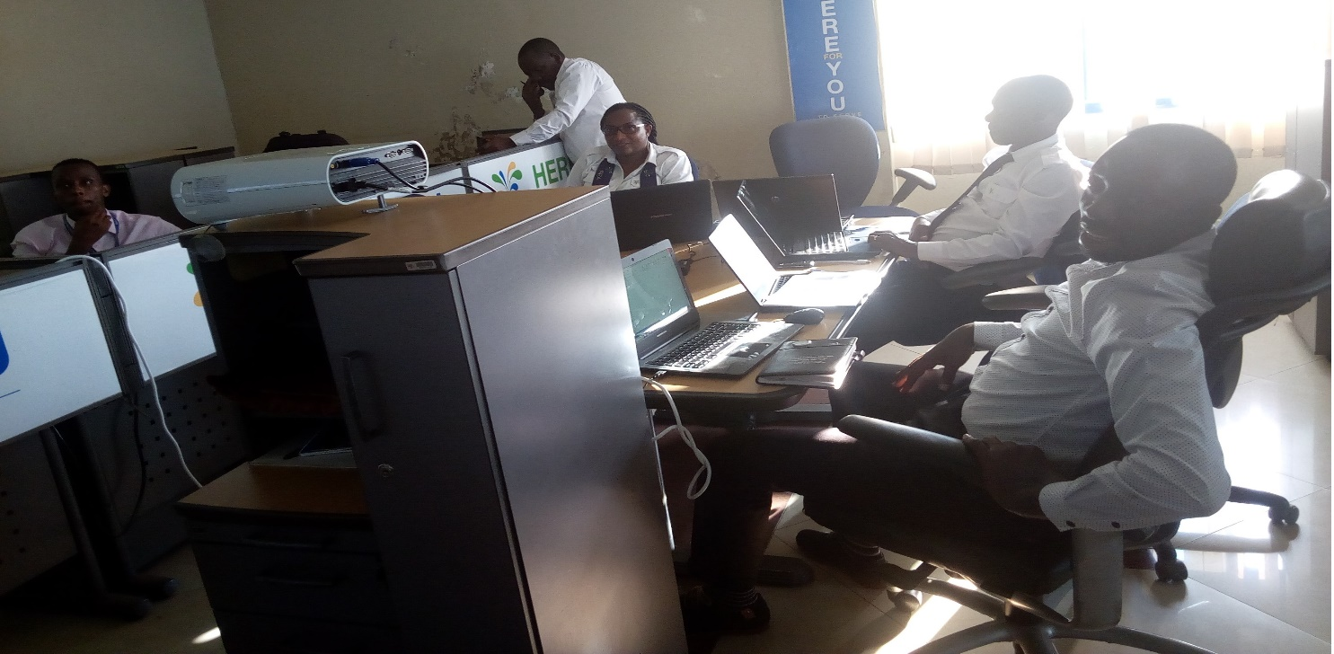

**Figure 1: Photo taking during one of the classes**

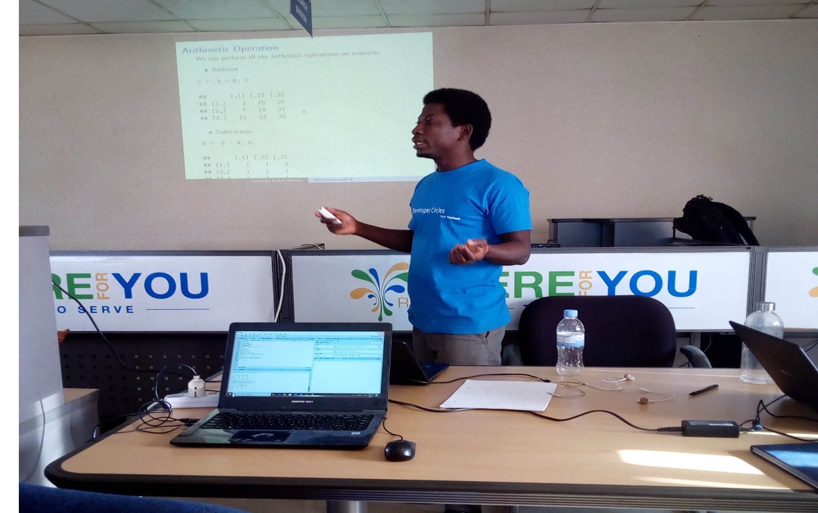

**Figure 2: Photo taking during one of the classes**